Reynolds United Methodist Church
December 3, 2017 – First Sunday of Advent
______________________________________________________________
Gathering
Greeting
The All Church Memory Verse of the Month: Hebrews 13:2 (NIV)
Do not forget to show hospitality to strangers, for by so doing some people have shown hospitality to angels without knowing it. Hebrews 13:2

Lighting of the Advent Candle(s) (Spoken and Sung) The Yocum Family
Reader 1: O God, we light the first candle of Advent.
(A member of a family lights the first candle.)
Reader 2: We kindle it with hope. We long for you to come to our world, to break through and reign with justice and peace, so that we may experience joy, and know your love.
Reader 1: The prophet Isaiah also cried to God, to tear open heaven and come down. He called God's people to do right. Isaiah called them to be refashioned like clay by God, the potter. He recalled God’s promises that God would be their God, and they would be God’s people. This Advent, we call out to God.
All: Mighty God, creator of the world, break through all that keeps us from you. We ask for your mercy and pray that you would re-form us in your image. This Advent, visit us with your justice, love, and peace.
People sing (to the tune of “Come, Thou Long Expected Jesus)
Shine on us, O God of justice;
Guide our path through gloom of night;
Bear within us Wisdom's glory;
Come to us, O Christ the Light.
Voices In Praise “Hark the Herald/King of Heaven” ~ Paul Baloche
Proclaiming God’s Word
Children’s Moment: Michelle Bartlett
Scripture Lesson: Isaiah 64:1-9 Bill Kirchhofer
Message “The Waiting is the Hardest Part?” Pastor Seamus

Responding to The Word
Intercessory Prayer Sharing of Joys and Concerns
Presentation of Tithes and Offerings
Offertory “O Come, o Come Immanuel” UMH 211
Singing of Our Doxology (UMH 95)
Dedication of the Offering

The Great Thanksgiving
The Lord’s Prayer
The Sacrament of Holy Communion

Sending Forth (Going into the world/into the week)
Announcements (See Bulletin, below)
Sending Song: “My Hope Is In You” ~ Aaron Shust
Benediction
Postlude

CHURCH CALENDAR
Wednesday, December 6 – Wednesday Morning Bible Study, Isaiah 40:1-11.
Sunday, December 3 – Hub Cluster Advent service, 2:00 pm at Chana UMC
Monday, December 11 – Annual Charge Conference, 7 pm.

ANNOUNCEMENTS
Our Mission focus for December is H.O.P.E. of Rochelle

The Harvest Festival goal is $4500 to provide for the purchase and installation of a backup generator for the church. Offerings to date total $4350!

On Monday December 11th the Ashton United Methodist is hosting a Christmas tea at 7 pm.
Reservations are requested by Friday December 9th 815-453-2328.

To submit items for the newsletter, please email Kathy Clark; kathleenaclark@comcast.net

Serving this Sunday, December 3
Ushers for December: Karen Yocum, Judy Light, Susie Miller, Shannon Brown
Greeters: Denny & Penny Bennett
Liturgist: Bill Kirchhofer
Youth Moment: Kathy Clark
Communion Steward November: Kathy Becker
Church Hostess for November: Contact Judy Light
Coffee Fellowship Time: Brake & Heimbaugh families

Snow Removal: As Needed

Serving next Sunday, December 10
Ushers for December: Karen Yocum, Judy Light, Susie Miller, Shannon Brown
Greeters: Vernon & Nancy Gittleson
Liturgist: Justin Rueff
Youth Moment: Children’s Program
Communion Steward November: Kathy Becker
Church Hostess for November: Contact Judy Light
Coffee Fellowship Time: Brown family

Snow Removal: As Needed

Last week’s Offering: Church Fund 1,155.00
Harvest Festival 500.00
Church Rental - Fellowship Hall 100.00
Glabes 151.00

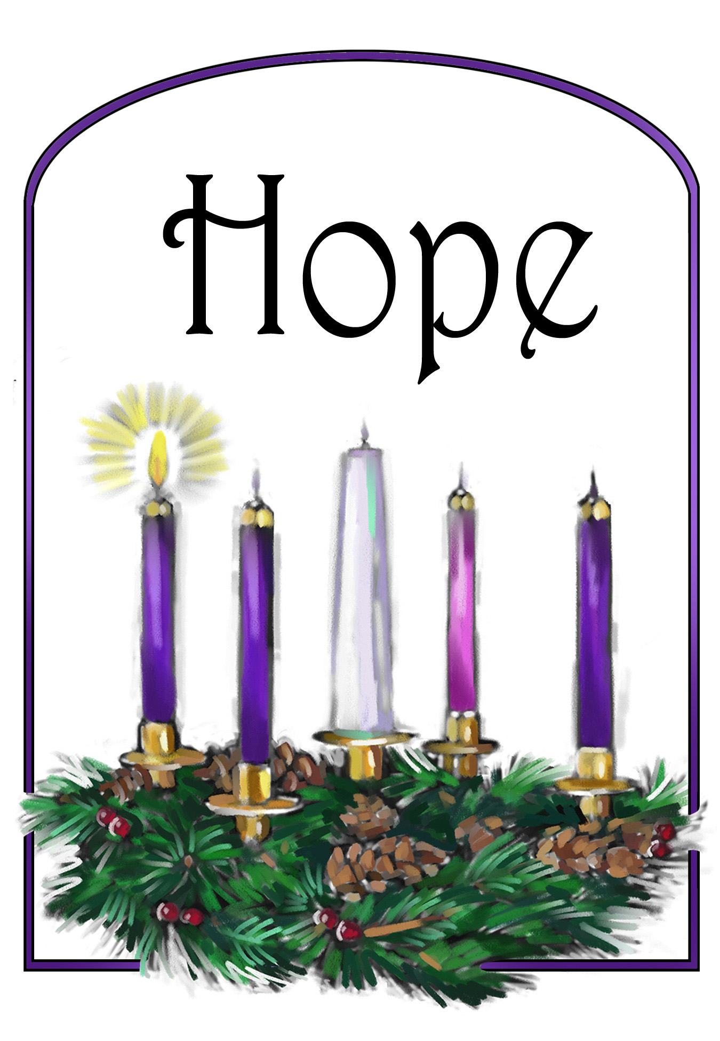

Reynolds United Methodist Church
2496 Reynolds Road
Ashton, IL 61006
(815) 453-2513
E-mail: reynoldsumc@oglecom.com
Web Site: www.reynoldsumc.net
Pastor: Seamus Enright

